**Course Code: ITA0447**

**Course Title: STATISTICS WITH R PROGRAMMING FOR NLP**

**LAB DAY : 02**

1. Write a R program to create an array, passing in a vector of values and a vector of dimensions. Also provide names for each dimension.

CODE:

values <- c(1, 2, 3, 4, 5, 6, 7, 8, 9)

dims <- c(3, 3)

dim_names <- list(c("Rows 1", "Rows 2", "Rows 3"), c("Columns 1", "Columns 2", "Columns 3"))

my_array <- array(values, dim = dims, dimnames = dim_names)

print(my_array)

OUTPUT:

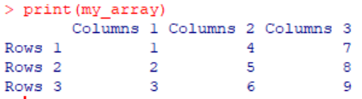

1. Write a R program to create an array with three columns, three rows, and two "tables", taking two vectors as input to the array. Print the array.

CODE:

vec1 <- c(1, 2, 3, 4, 5, 6, 7, 8, 9)

vec2 <- c(10, 11, 12, 13, 14, 15, 16, 17, 18)

arr <- array(c(vec1, vec2), dim = c(3, 3, 2))

print(arr)

OUTPUT:

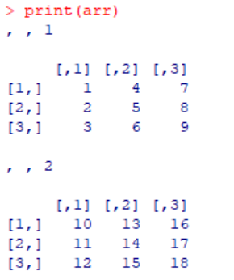

1. Write a R program to create a list of elements using vectors, matrices and a functions. Print the content of the list.

CODE:

vec <- c(1, 2, 3)

mat <- matrix(c(4, 5, 6, 7, 8, 9), nrow = 2)

myfun <- function(x) {

x^2

}

mylist <- list(vec, mat, myfun)

print(mylist)

OUTPUT:

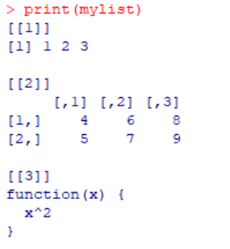

1. Write a R program to draw an empty plot and an empty plot specify the axes limits of the graphic

CODE:

plot.new()

plot.new(xlim = c(0, 20), ylim = c(0, 20))

OUTPUT:

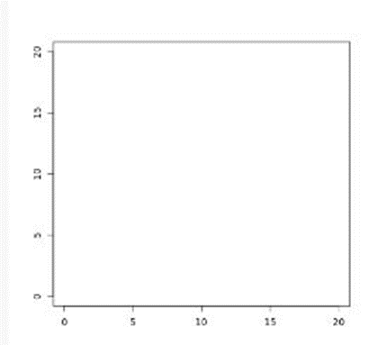

1. Write a R program to create an array of two 3x3 matrices each with 3 rows and 3 columns from two given two vectors. Print the second row of the second matrix of the array and the element in the 3rd row and 3rd column of the 1st matrix.

CODE:

print("Two vectors of different lengths:")

v1 = c(1,3,4,5)

v2 = c(10,11,12,13,14,15)

print(v1)

print(v2)

result = array(c(v1,v2),dim = c(3,3,2))

print("New array:")

print(result)

print("The second row of the second matrix of the array:")

print(result[2,,2])

print("The element in the 3rd row and 3rd column of the 1st matrix:")

print(result[3,3,1])

OUTPUT:

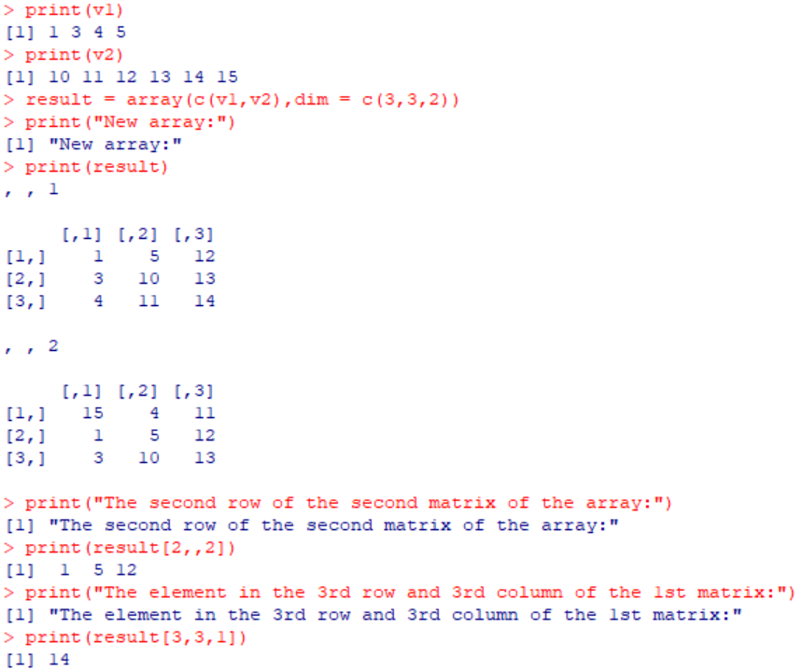

1. Write a R program to combine three arrays so that the first row of the first array is followed by the first row of the second array and then first row of the third array.

CODE:

arr1 <- array(1:9, dim = c(3, 3))

arr2 <- array(10:18, dim = c(3, 3))

arr3 <- array(19:27, dim = c(3, 3))

combined_arr <- rbind(arr1[1,], arr2[1,], arr3[1,])

print(combined_arr)

OUTPUT:

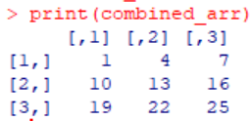

1. Write a R program to create an array using four given columns, three given rows, and two given tables and display the content of the array.

CODE:

v1 <- c(1, 2, 3)

v2 <- c(4, 5, 6)

v3 <- c(7, 8, 9)

v4 <- c(10, 11, 12)

mat1 <- cbind(v1, v2, v3, v4)

mat2 <- matrix(c(13:15), nrow = 1)

mat3 <- matrix(c(16:18), nrow = 1)

arr1 <- array(c(mat1, mat2, mat3), dim = c(3, 4, 2))

print(arr1)

OUTPUT:

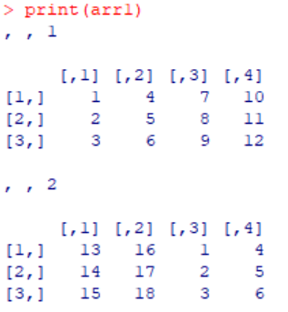

1. Write a R program to create a two-dimensional 5x3 array of sequence of even integers greater than 50.

CODE:

arr1 <- array(seq(from = 50, by = 2, length.out = 15), dim = c(5, 3))

print(arr1)

OUTPUT:

